Energy Modelling Notes

Decouple Podcast - The Last 10% of Gas Turbines
“The second category of solar maxers, I think they fall into the flaw of thinking that the solar battery gas system, which today is actually really hard to compete with. That is a cheap grid. If you're building a grid from scratch, yeah, that is a really cheap grid.

They conflate it and think that you can just get rid of the gas and that it will still be super cheap. One, in fact, the reason that you have that 10 percent of gas turbines in there is to prevent significant cost ballooning, which you see in a lot of academic modeling of 100 percent renewable versus all the alternatives as you're sort of trying to push the system all the way to that 100 percent solar. So I think, and then forget about it anywhere in the world where it's significantly cloudy, New England, Alaska, Mongolia, like Hokkaido, Japan.”

“The way I look at it I want an optimal system. Throw all the clean energy options into that system and then build what the model tells you to to build.”

From Decouple: Sun, Silicon, and Xinjiang, Jul 8, 2025, 1:05:11
https://youtu.be/jA5iLB1lJDA?si=PFkEn4GvuBYw58Q0

Seaver Wang, director of the Climate and Energy Research Program at The Breakthrough Institute

Casey Handmer: The Unstoppable Battery Onslaught
https://caseyhandmer.wordpress.com/2021/05/20/the-unstoppable-battery-cavalcade/

It’s a tradeoff between local storage and long distance power transmission. Temporal versus spatial arbitrage.

I should design a grid from the ground up to understand why that one guy on Decouple? said removing that last 10% of natural gas plants is so hard. We can make that net zero too! And will!

The new question I must answer is what will the grid look like in 20 years, what are the tradeoffs between different generation methods, and what is the market for batteries in this world.

Model costs trickling down to the consumer, this requires a way to model costs end-to-end. Cell to Panel to Distribution to Installer to Customer.

“In particular, annual growth in battery production investment has hovered around 250% for a while.“

The Australian grid might have good numbers on batteries, well why wouldn’t America’s?

Australian coal plants have never paid themselves back. Stranded assets.

“Texas has probably the cheapest natural gas in the history of the universe. They routinely flare it! And even so, batteries are so much cheaper that they’re out-competing gas by a factor of five.”

An expanding market for batteries induces more demand. Like Starlink. Unlike most industries, where an expanding product has less demand. Now this requires a proof!

Grids use generation frequency as a feedback mechanism to regulate production.

Power is usually sold in 30 minute or 24 hour chunks in advance?

Synchroverter = virtual synchronous generators, inverters mimicking synthetic inertia. Far more responsive than any spinning mass.

“Mismatch between supply and demand in the grid is signaled via tiny shifts in frequency.”

“Installing batteries is similar to high frequency trading (HFT) in that it exploits market inefficiencies to both improve the functioning of the market, provide liquidity, and generate revenue.”

Different from HFT in that geographic collocation is less important and legacy systems are not forced out of the market by newer systems.

Integrating load shifting batteries with renewable energy systems (Solar, wind) increases usage duty cycle.

“Uber offered a way for car owners to extract equity from their car, even as they serviced loans on it!”
This is a good way to model customer-owned robotaxis as well. Accelerating depreciation for extraction of equity, and generation of more capital.

Uber involuntarily transferred value for taxis to themselves.

“There is no practical limit to battery installation on a given grid due to competition with traditional operators.”

This is a transitory advantage, in the limit you have to model batteries differently. But this is the path taken, and grid buildout of batteries may be path dependent.

Use batteries to load shift load into the evening. The natural end state is 5-15x solar capacity overbuild.

Consider fixed asset payback times for solar and batteries.

On Australia:
“What would they prefer? Robust, publicly owned solar and battery plants within reach of central control, regulation, and taxation? Or the continuing proliferation of totally unregulated virtual local grids with almost all solar and batteries behind the meter, where consumers bear the marginally higher capital costs upfront and then keep their cheap electricity forever, largely out of reach of the official utility concessions?”

“If Australia’s coal and gas operators don’t like the big batteries popping up like mushrooms, they’re really going to hate the proliferation of batteries behind the meter.”

“Broadly speaking, demand varies slowly throughout the day in a predictable way, and there is always enough latent capacity to keep the grid stabilized.”

If your battery wants to increase grid stability, just charge/discharge in response to frequency variations.

“In contrast, a strategy oriented toward maximum revenue would allow frequency to fall while spot price increased, dumping limited power to maximize the area under the curve.”
“Consider a sudden rise in electricity demand caused by, say, a Victorian coal generator tripping. The battery can manipulate the shape of this rise. If the gas peaker plant starts up, the battery can flood the market, diminishing the price and cutting the peaker’s revenue. If the peaker does not start, the battery can enjoy a high level of revenue for as long as the demand persists.”

“...with almost perfect deniability.”

“The software required to do this is simple enough that it could be coded up in a weekend by any motivated high school student taking a break from generating trading algorithms on Numerai.” lol

“While a sufficiently expert regulator could insist on a set of public standards on metrics, APIs, and falsifiable strategies” … BMS owners won’t want to give up data.

Casey Handmer: Grid Storage: Batteries Will Win
https://caseyhandmer.wordpress.com/2023/07/12/grid-storage-batteries-will-win/

New solar plants take 5-20 years to pay off.

“And while batteries have a fixed cost per MWh delivered (that is falling about 10% per year), transmission lines get more expensive as they get longer.”
Is that true? How does the cost of transmission lines scale?

Model it where a battery becomes better than a transmission line at a given length. This length gets shorter by the year. “Competitive length for transmission lines.”

There’s more temporal difference in energy demand than spatial.

NERC region is a self contained grid, which interfaces with others? Like ERCOT.
NERC = North American Electric Reliability Council
ERCOT = Electric reliability council of Texas

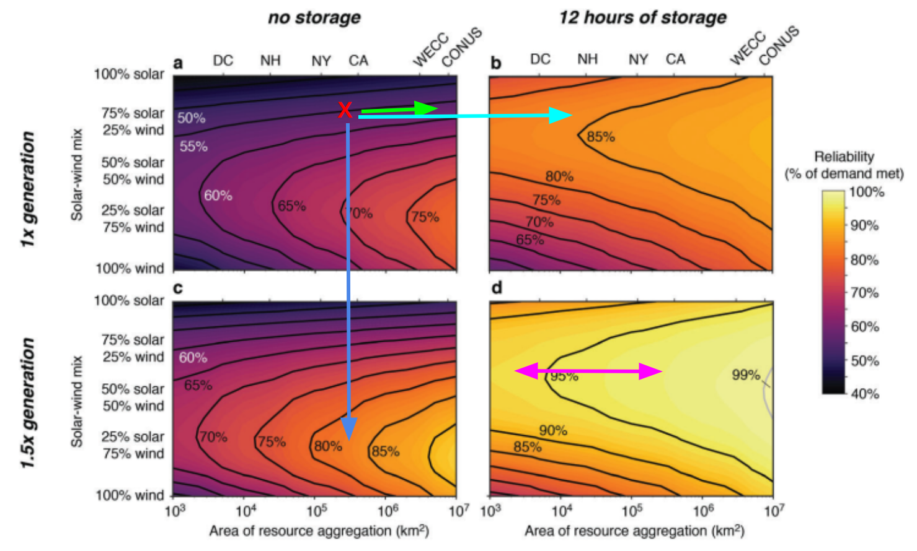
Chart from this paper:
https://drive.google.com/file/d/1C0AnY_NoP5gbSRrh6E7NJKzagaXtWyCI/view

Green line = More transmission
Light blue = More storage
Dark blue = More generation

Pink arrow = adding / subtracting transmission in a situation with more wind, solar, and batteries

Area of resource aggregation seems to refer to how dispersed production is.

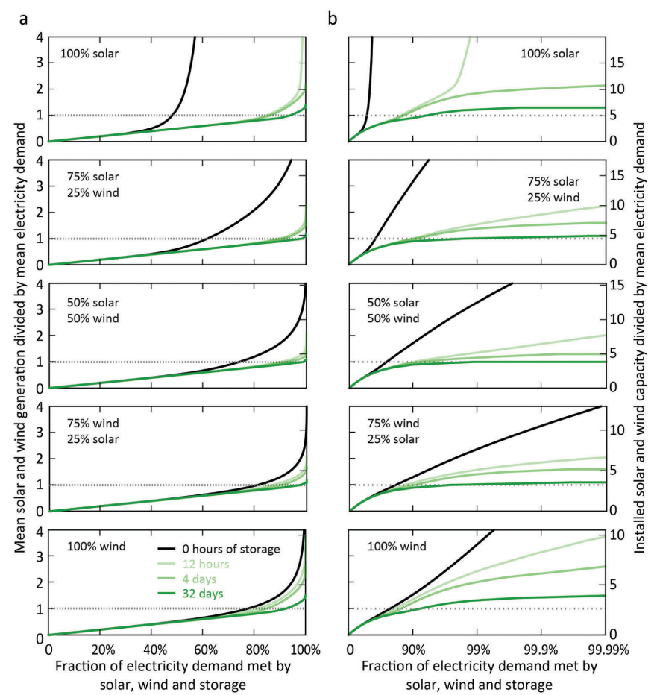

This chart shows that with 12 hours of battery storage and ~8x nameplate overbuild we can get 99.99% reliability (Handmer says this is better than existing grids).

https://www.bchydro.com/content/dam/BCHydro/customer-portal/documents/corporate/accountability-reports/financial-reports/annual-reports/2023-24-annual-service-plan-report-cs-5002.pdf

Page 10 (14) of the BC Hydro report above reports 3.56 9s for 2023-24. 99.96% reliability. Doesn’t the industry aim for six 9s?!?!

For powering data centers like this, have to consider the edge case of buying up stranded gas assets for power, eg. Marcellus basin.

Casey Handmer: Solar and batteries for generic use cases
https://caseyhandmer.wordpress.com/2024/11/09/solar-and-batteries-for-generic-use-cases/

Stable attractor: a set of states to which systems tend to evolve. A state which systems tend to.

“They are (asymptotically) stable in the sense that the dynamical system evolves such as to approach the attractor in whose vicinity the system starts out.”

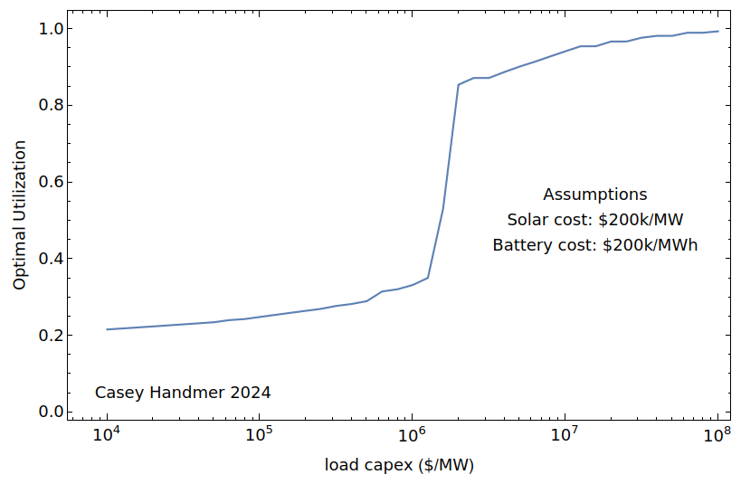

Cost-optimal utilization has an extremely significant knee in its curve. Below $1000/kW load cost, best to run it at low utilization to get a cheaper power system (pure solar), above and you get cheaper by using batteries.

As the Solar-Battery cost ratio increases, the line moves right.

Casey Handmer: The future of electricity is local
https://caseyhandmer.wordpress.com/2020/12/27/the-future-of-electricity-is-local/

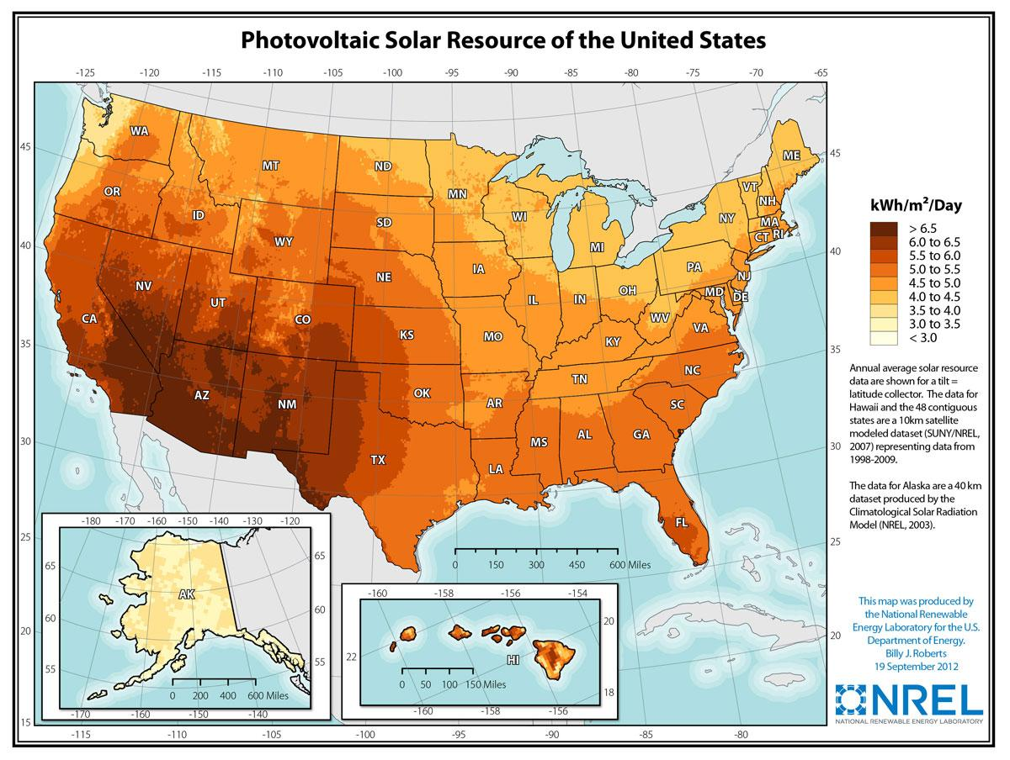


Solar resource (kWh/day) varies up to 3x from the highest mountains and deserts (Sahara or Andes) to the cloudiest highest-latitude (eg. Scotland, or around Chongqing) places on Earth.

Note: Chongqing has many mountains and is extremely cloudy (more than Vancouver). Xichang launch site is west of it.

